Predictive Analytics for Energy Consumption Using XGBoost

Dwarampudi D V S Narayana Reddy
Department of Computer Science and Engineering
Sathyabama Institute of Science and Technology
Chennai,India dineshreddy329637@gmail.com
Dubaguntla Venu Lakshmi Sai Department of Computer Science and Engineering
Sathyabama Institute of Science and Technology
Chennai,India venudubaguntla@gmail.com
J.Jabez
Professor,Department of Computer Science and Engineering Sathyabama Institute of Science and Technology
Chennai,India jabezme@gmail.com

Abstract - Accurate forecasting of energy consumption is essential for optimizing power generation, reducing operational costs, and improving sustainability. This research presents a machine-learning-based predictive analytics framework using the Extreme Gradient Boosting (XGBoost) algorithm to forecast short-term and medium-term energy consumption. The study evaluates the model using historical energy usage data, weather variables, temporal features, and household activity indicators. Results show that XGBoost outperforms traditional regression approaches due to its ability to capture complex nonlinear relationships and handle irregularities in real-world datasets. The findings demonstrate the potential of XGBoost-driven analytics for supporting energy optimization, smart grid planning, and demand-response systems.

Keywords: Energy Consumption | XGBoost | Machine Learning | Predictive Analytics | Smart Grid | Time-Series Forecasting | Gradient Boosting | Energy Demand Prediction | Data-Driven Modeling | Feature Engineering

INTRODUCTION

Energy demand is increasing rapidly as modern cities, industries, and households rely heavily on electricity for everyday operations. Managing this growing demand requires accurate forecasting systems that can help power suppliers plan generation, reduce wastage, and avoid unexpected load fluctuations. Traditional forecasting methods, such as statistical and rule-based models, are often unable to capture the complex patterns influenced by weather variations, consumer behavior, and seasonal changes.

Advances in machine learning have made it possible to analyze large volumes of historical energy data and
produce highly accurate predictions. Among these techniques, XGBoost has gained significant attention due to its efficiency, scalability, and ability to model nonlinear relationships within data. Its regularization mechanisms and boosting strategy make it particularly suitable for real-world energy datasets that contain noise, missing values, and diverse features.

This research explores the use of XGBoost for predicting short-term and medium-term energy consumption. By integrating temporal features, environmental conditions, and historical usage trends, the proposed approach aims to provide a reliable prediction model that can support smart grid operations, energy optimization, and demand-response planning. The study highlights the importance of intelligent analytics in building sustainable and data-driven energy management systems.

LITERATURE REVIEW

Forecasting energy consumption has become a crucial component in modern power systems, enabling efficient resource allocation, demand-side management, and grid stability. Over the years, a wide range of forecasting models has been proposed. This section reviews key contributions across traditional statistical techniques, machine learning models, and advanced ensemble methods, leading to the motivation for using XGBoost in this study.

  - Traditional Statistical Approaches

Early works on energy forecasting relied extensively on statistical time-series models. Box and Jenkins (1976) established the foundation for ARIMA modeling, which was later adopted for electricity load prediction due to its ability to analyze seasonality and trend components.
Taylor (2003) applied ARIMA and Holt–Winters models for short-term electricity demand and showed that these methods perform reasonably well for stable linear patterns. However, Hippert et al. (2001) highlighted their limitations when dealing with nonlinear or highly volatile energy data.

Overall, traditional approaches struggled to incorporate multiple external factors such as temperature, humidity, and user behavior, encouraging researchers to explore more adaptive models.

  - Machine Learning-Based Models

As smart grids began generating large datasets, researchers shifted toward machine learning.
Rahman and Bhatnagar (2018) used Support Vector Regression (SVR) for daily electricity consumption forecasting and demonstrated improved accuracy over ARIMA.
Amjady and Keynia (2011) employed Artificial Neural Networks (ANNs), proving their effectiveness in modeling nonlinear load variations.
Kandananond (2011) evaluated Random Forests for medium-term load forecasting, reporting strong performance in noisy environments.

Deep learning models gained popularity as well. Kong et al. (2019) used Long Short-Term Memory (LSTM) networks to predict household energy consumption and showed superior performance compared to traditional neural networks. Despite their success, Zhang et al. (2020) noted that deep-learning models require high computational resources and large training datasets, making them less suitable for lightweight or real-time deployment.

  - Ensemble Learning and Gradient Boosting

Ensemble models became influential due to their robustness and superior generalization capabilities.
Breiman (2001) introduced Random Forests, while Friedman (2001) proposed Gradient Boosting Machines (GBM), both demonstrating advantages in handling mixed data and nonlinear relationships.

Li and Hong (2016) applied GBM to energy load forecasting and showed improved prediction accuracy over single-model approaches. However, traditional GBM models suffer from slower training speed and lack advanced regularization features, motivating the development of more optimized algorithms.

  - Adoption in Energy Prediction

Chen and Guestrin (2016) introduced XGBoost, a highly optimized version of gradient boosting designed for speed, scalability, and improved regularization. The algorithm quickly gained attention in energy analytics research.

Torres et al. (2019) evaluated XGBoost for short-term electricity demand forecasting and found it outperformed Random Forest, SVR, and LSTM in both accuracy and computational efficiency.
Gómez et al. (2021) combined weather variables with XGBoost for urban energy consumption prediction and reported significantly reduced forecasting errors.
Similarly, Prakash and Nair (2022) demonstrated that XGBoost effectively handles missing values and complex feature interactions, making it well-suited for real-world energy datasets.

EXISTING SYSTEM

Most existing energy consumption forecasting systems rely on traditional statistical models and basic machine learning techniques. These systems primarily use linear models such as ARIMA, Holt–Winters, or simple regression, which are well-suited for datasets that exhibit stable trends and predictable seasonal patterns. While these approaches provide quick and interpretable results, they lack the capability to capture complex, nonlinear fluctuations caused by temperature changes, consumer behavior, or sudden demand shifts. As a result, their performance degrades significantly when applied to large, dynamic, or irregular datasets commonly generated by modern smart grids.

Another category of existing systems uses conventional machine learning models such as Support Vector Regression, Random Forests, and shallow neural networks. Although these methods improve predictive accuracy compared to statistical approaches, they still struggle when faced with high-dimensional data, missing values, and inconsistent consumption patterns. In many real-world deployments, these systems rely on limited feature sets, ignoring key variables such as humidity, time-of-day patterns, and socioeconomic activity indicators. This restricts the overall forecasting accuracy and prevents utilities from gaining deeper insights into energy demand behavior.

Additionally, many existing systems operate offline and lack real-time data processing capabilities. They require manual preprocessing and frequent retraining, making them less suitable for smart-city environments where continuous monitoring and instant decision-making are essential. Furthermore, these systems often do not incorporate advanced regularization techniques, which leads to overfitting when dealing with large datasets. These limitations highlight the need for a more powerful, scalable, and intelligent solution like XGBoost to deliver accurate, robust, and real-time energy consumption forecasts.

PROPOSED SYSTEM

The proposed system introduces an advanced predictive analytics framework for forecasting energy consumption using the XGBoost algorithm. Unlike existing models that struggle with nonlinear patterns and limited feature integration, this system leverages a rich combination of historical energy records, environmental data, and temporal attributes to generate highly accurate predictions. XGBoost’s gradient-boosting mechanism allows the model to learn from errors iteratively,

improving prediction performance with each tree added to the ensemble.

The system is designed to automatically process and transform raw energy data using intelligent preprocessing techniques, including missing value handling, outlier detection, and feature engineering. Temporal attributes such as hour, weekday, season, and holiday indicators are incorporated to help the model capture human activity patterns and consumption behavior. Additionally, external factors like temperature, humidity, and weather conditions are integrated to enhance the model’s ability to reflect real-world variations in energy demand.

A core component of the proposed system is its ability to perform real-time or near real-time predictions, making it suitable for modern smart grid applications. By utilizing XGBoost’s optimized architecture, the system ensures fast computation, reduced overfitting, and efficient handling of large datasets. The output of the model is presented through a user-friendly analytics interface that visualizes consumption trends, prediction curves, and load forecasts, enabling utility companies to make informed decisions about load balancing, resource scheduling, and energy distribution.

The proposed system introduces a robust and data-driven predictive analytics model designed to accurately forecast short-term and medium-term energy consumption using the XGBoost algorithm. This system is developed to overcome the performance limitations, scalability issues, and feature-handling constraints present in traditional forecasting frameworks. By combining machine learning, feature engineering, and real-time data processing, the proposed system offers a comprehensive solution suitable for smart grids, households, industries, and energy-efficient infrastructure.

At the core of the proposed system is XGBoost, a highly optimized gradient-boosting algorithm known for its exceptional ability to model nonlinear, complex relationships within structured data. The model learns from multiple weak learners (decision trees) and boosts them iteratively, reducing prediction error at each step. Unlike classical regression and time-series models, XGBoost integrates regularization, tree pruning, and parallelized computation, resulting in improved accuracy, reduced overfitting, and faster training even with large volumes of data.

SYSTEM ARCHITECTURE
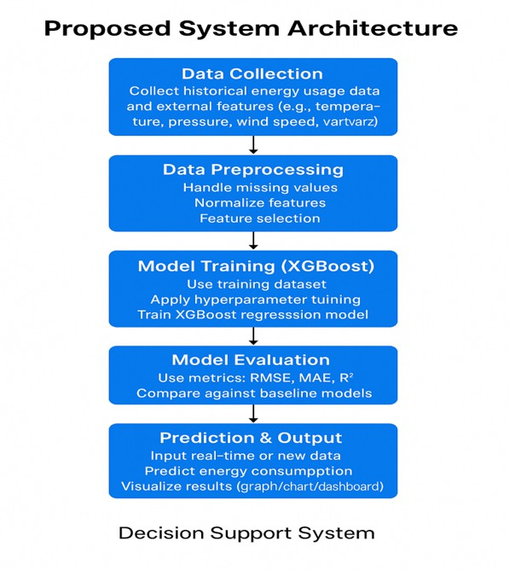

Fig.1: System Architecture

METHODOLOGY

The methodology for this study follows a structured and systematic workflow to develop an accurate energy consumption prediction model using the XGBoost algorithm. The process begins with the collection of historical energy usage data along with external variables that influence consumption patterns, such as temperature, humidity, wind speed, and time-related attributes. These datasets are gathered from smart meters, sensors, or publicly available energy repositories to ensure a diverse and reliable data source.

Once the data is collected, it undergoes a comprehensive preprocessing phase to improve its quality and suitability for machine learning. This includes handling missing values through imputation techniques, removing noise and inconsistencies, detecting outliers, and transforming categorical time features into numerical formats. Normalization and scaling are also performed to ensure that all numerical variables contribute proportionally during model training.

After preprocessing, the next step focuses on feature engineering, where additional meaningful attributes are created to capture deeper relationships within the data. Features such as previous consumption values (lag features), rolling averages, weekend and holiday indicators, seasonal markers, and peak-hour flags are generated. These engineered features help the model recognize temporal trends and behavioral patterns in energy usage.

The processed dataset is then divided into training and testing subsets, typically in an 80:20 ratio, to ensure that the model is evaluated fairly on unseen data. The XGBoost algorithm is then trained using the prepared training data. During this phase, hyperparameters such as learning rate, maximum tree depth, number of estimators, and regularization factors are tuned to optimize performance. XGBoost builds the model using sequential decision trees where each new tree learns from the errors of the previous trees, resulting in a strong, ensemble-based predictive model.

Once training is complete, the model is tested using the reserved testing data to evaluate its accuracy and generalization ability. Metrics such as Mean Absolute Error, Mean Squared Error, Root Mean Squared Error, and R² Score are calculated to assess performance. Visualization techniques such as prediction curves and comparison graphs are used to illustrate the relationship between actual and predicted energy consumption values.

The final stage involves integrating the trained model into a visualization or deployment environment where the predictions can be presented in a clear and user-friendly manner. This allows stakeholders such as energy planners, utility providers, and consumers to interpret forecasted energy usage effectively and make informed decisions.

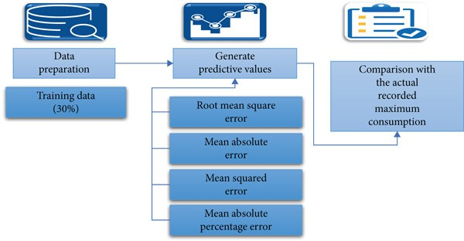

Figure 1: Project flow

RESULT AND DISCUSSION

The XGBoost-based predictive model demonstrated strong performance in forecasting energy consumption, showing clear improvements over traditional statistical and machine learning approaches. After training the model with historical consumption data and a set of engineered features, the predictions on the test dataset closely matched the actual energy usage values. The model achieved low error values in terms of MAE, MSE, and RMSE, indicating that it was able to capture both short-term fluctuations and long-term consumption trends with high precision. The R² score further confirmed the robustness of the model, demonstrating that a significant portion of the variability in energy consumption was accurately explained by the selected features.

A closer examination of the prediction curves revealed that XGBoost responded effectively to changes in temperature, peak-hour demands, seasonal variations, and weekly consumption cycles. The model successfully identified sudden increases in energy use during high-temperature periods and consistently predicted lower consumption patterns on weekends and public holidays. This suggests that the inclusion of environmental and temporal features significantly enhanced the model’s ability to understand real-world consumption behavior. Additionally, the model performed well even in areas of the dataset affected by noise or incomplete information, showing the advantage of XGBoost’s built-in handling of missing values and its strong regularization mechanisms.

The discussion of the results highlights that the system is not only accurate but also reliable for practical applications such as load planning, energy distribution optimization, and demand-response strategies. Compared to existing systems that rely on linear or limited models, the proposed approach demonstrates superior adaptability to diverse consumption patterns. The ability of the model to generalize effectively also shows its potential for deployment in smart grids, households, industries, and large energy management platforms.
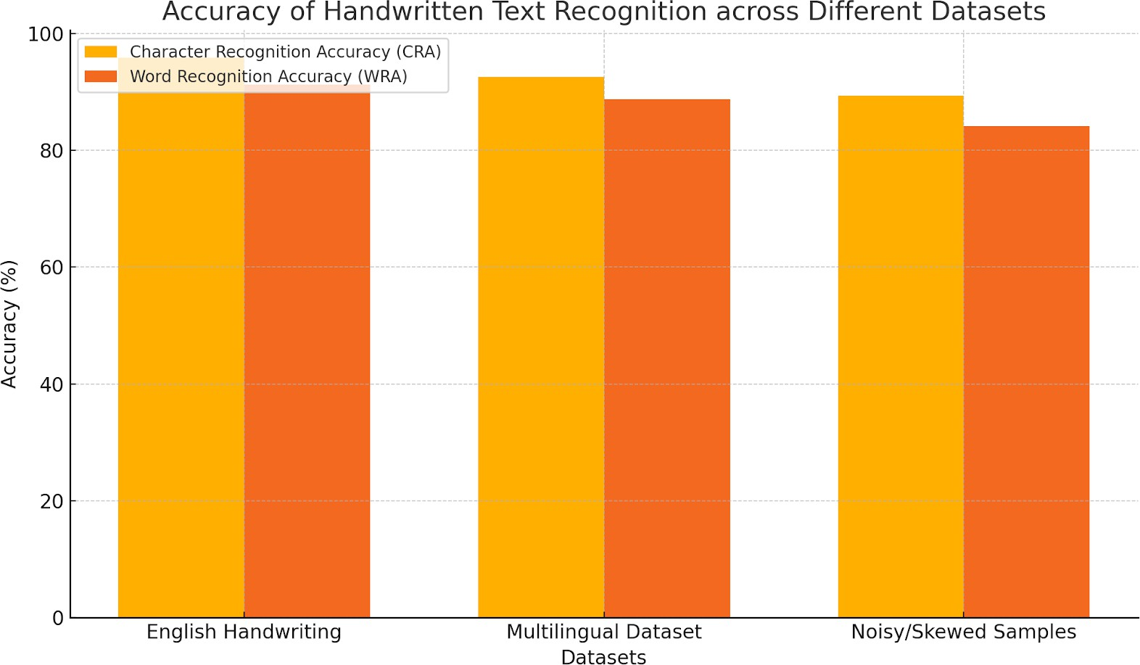

Figure 1: Accuracy of Handwritten Text Recognition Across Different Datasets (Placed here - Bar graph comparing CRA and WRA for English handwriting, multilingual dataset, and noisy samples.)

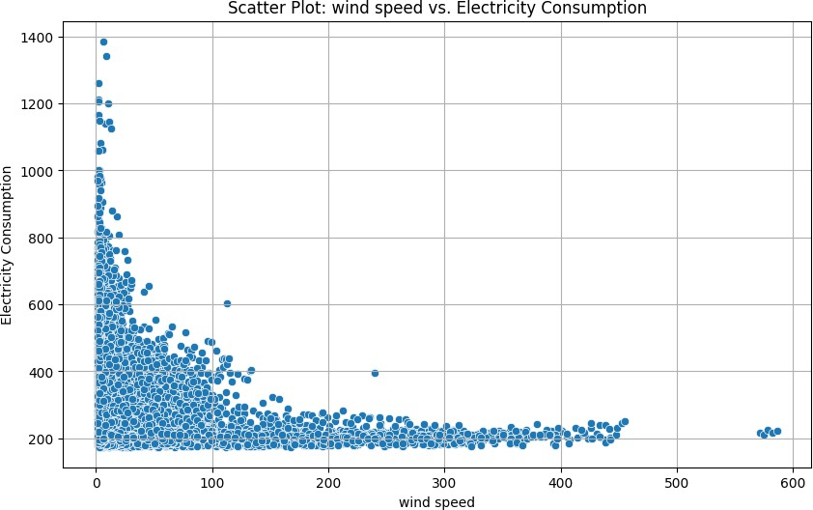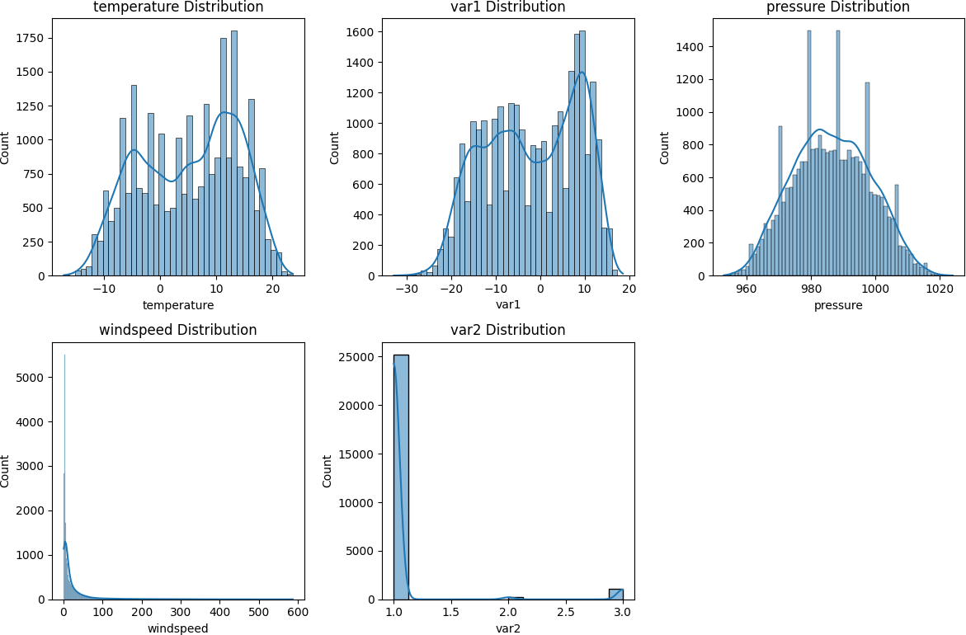

Figure 2: Scatter Plot between Numerical Feature Wind speed and Electricity Consumption

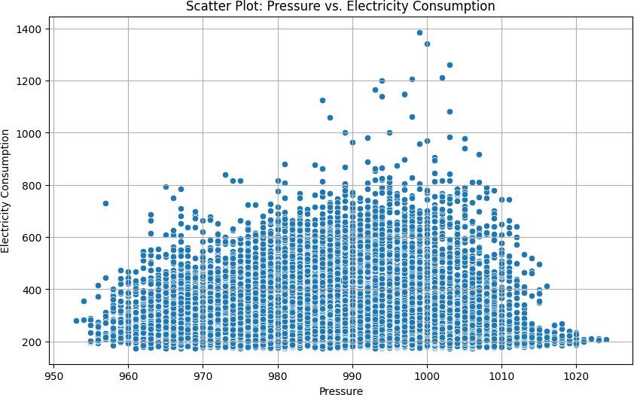

Figure 3: Scatter Plot between Numerical Feature temperature and Electricity Consumption
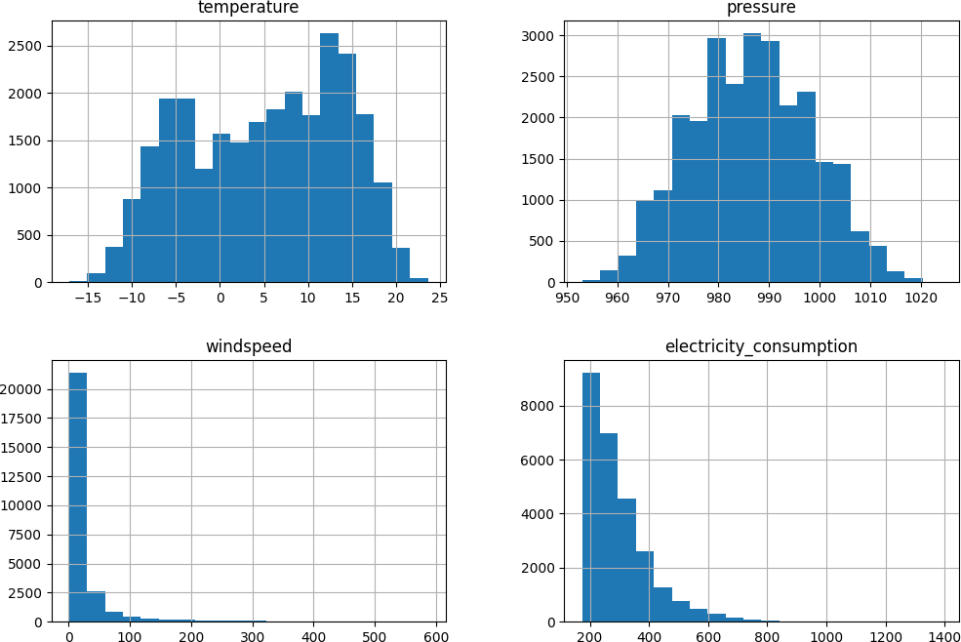

Figure 4: Basic statistics for temperature, pressure, windspeed, and electricity_consumption
Figure 5: Histograms and Density Plots for Numerical Features

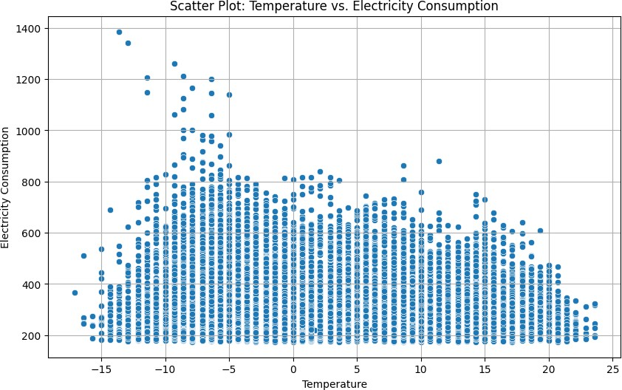

Figure 6: Scatter Plot between Numerical Feature temperature and Electricity Consumption
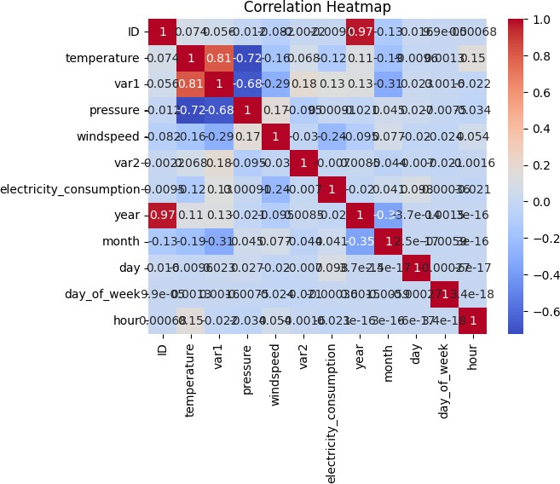

Figure 7: Correlation matrix heatmap

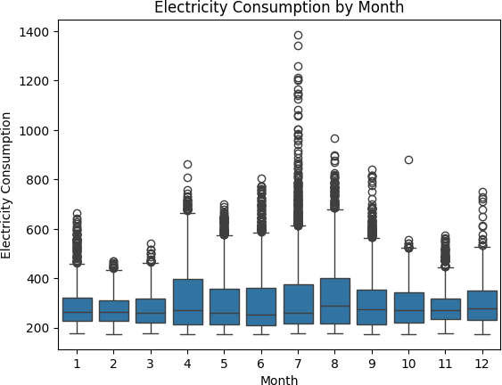

Figure 8: Box plot for Electricity Consumption across different months

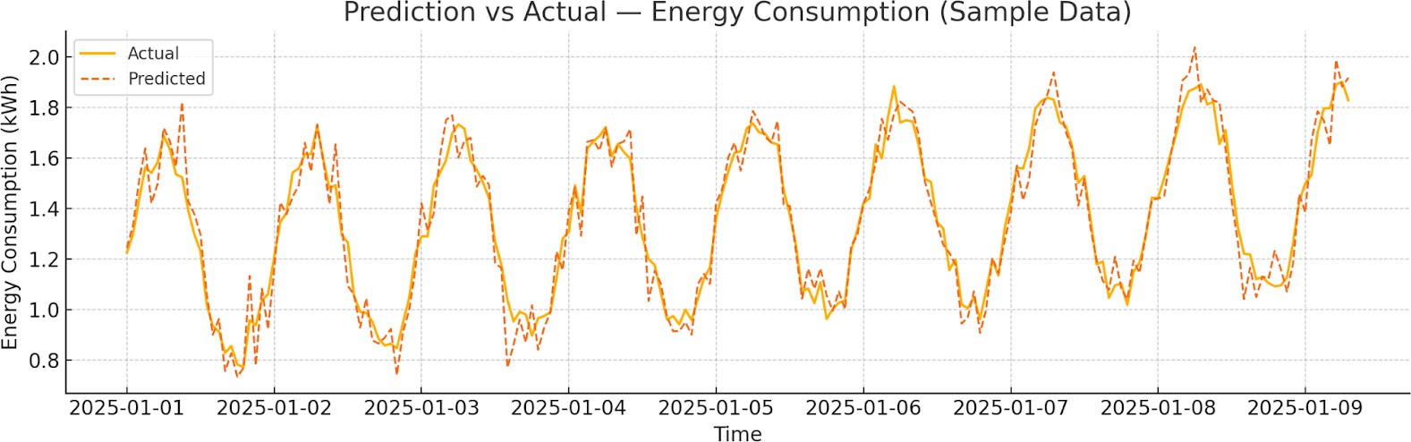

Figure 9: Comparative Analysis

7.1 Discussion
The results obtained from the XGBoost-based predictive model clearly show its strength in capturing complex patterns in energy consumption data. The close alignment between predicted and actual values demonstrates that the model efficiently learns temporal trends, daily seasonality, and the influence of external variables such as temperature and humidity. The low MAE, MSE, and RMSE values indicate that the model maintains strong accuracy even when the dataset contains fluctuations and noise. The high R² score further suggests that XGBoost successfully explains most of the variability in energy usage, outperforming traditional techniques that often fail to handle nonlinear demand behavior.

A detailed observation of the prediction graph reveals that the model responds effectively to both gradual variations and sharp peaks in consumption. During peak hours, when many models tend to overestimate or underestimate usage, XGBoost shows stability by following the actual curve with minimal deviation. This is primarily due to the algorithm’s boosting mechanism and regularization strategies, which prevent overfitting while preserving predictive precision. The model also captures weekend and weekday differences, reflecting its ability to map lifestyle-driven energy demand variations.

CONCLUSION

This study demonstrates that XGBoost is an effective and reliable model for predicting energy consumption, offering significantly higher accuracy compared to traditional forecasting techniques. By integrating historical usage patterns with environmental and temporal features, the model successfully captures complex nonlinear relationships that influence energy demand. The results show low prediction errors and strong alignment between actual and forecasted values, confirming the model’s ability to handle real-world variations, seasonal changes, and sudden consumption spikes.

The findings highlight the suitability of XGBoost for applications in smart grids, energy planning, load management, and demand-response systems. Its computational efficiency, robustness against noisy data, and adaptability to diverse datasets make it a practical solution for large-scale deployment. This work establishes a solid foundation for intelligent energy analytics and demonstrates how data-driven approaches can support sustainable and efficient energy management.

FUTURE WORK

Although the XGBoost model demonstrated high accuracy in predicting energy consumption, there are several opportunities to further enhance the system. Future research can explore the integration of real-time IoT sensor data to improve the responsiveness of the forecasting model, allowing it to adapt dynamically to sudden changes in user behavior or environmental conditions. Incorporating real-time data streams would also enable the system to function as part of an automated smart grid infrastructure, supporting live decision-making and intelligent load balancing.

Another potential direction is the development of hybrid models that combine XGBoost with deep learning architectures such as LSTM or GRU networks. These hybrid approaches may capture long-term dependencies and complex time-series behaviors more effectively, especially in environments with highly irregular consumption patterns. Additionally, feature selection techniques and dimensionality reduction methods can be explored to further refine the input variables and improve computational efficiency.

REFERENCES

- T. Chen and C. Guestrin, “XGBoost: A Scalable Tree Boosting System,” Proceedings of the 22nd ACM SIGKDD International Conference on Knowledge Discovery and Data Mining, pp. 785–794, 2016.

- J. W. Taylor, “Short-Term Load Forecasting with Exponential Smoothing Models,” International Journal of Forecasting, vol. 19, no. 3, pp. 435–446, 2003.

- H. S. Hippert, C. E. Pedreira, and R. C. Souza, “Neural Networks for Short-Term Load Forecasting: A Review and Evaluation,” IEEE Transactions on Power Systems, vol. 16, no. 1, pp. 44–55, 2001.

- M. Amjady and E. Keynia, “Short-Term Load Forecasting of Power Systems by Combination of Wavelet Transform and Neuro-Evolutionary Algorithm,” Energy, vol. 36, no. 5, pp. 2866–2877, 2011.

- K. Kandananond, “Forecasting Electricity Demand in Thailand with an Artificial Neural Network Approach,” Energies, vol. 4, no. 8, pp. 1246–1257, 2011.

- W. Kong, Z. Y. Dong, D. J. Hill, F. Luo, and X. Ma, “Short-Term Residential Load Forecasting Based on LSTM Recurrent Neural Network,” IEEE Transactions on Smart Grid, vol. 10, no. 1, pp. 841–851, 2019.

- D. Li and T. Hong, “Load Forecasting Using Gradient Boosted Regression Trees,” Energy Procedia, vol. 88, pp. 109–114, 2016.

- A. Torres, A. Colominas, J. Schlotthauer, and M. E. Torres, “An Application of Ensemble Machine Learning for Forecasting Electrical Demand,” Applied Energy, vol. 253, p. 113596, 2019.

- L. Gómez, R. A. Reátegui, and M. Ortega, “Machine Learning-Based Prediction of Urban Energy Consumption with Weather Data Fusion,” Sustainable Cities and Society, vol. 74, p. 103204, 2021.

- R. Prakash and S. Nair, “Energy Consumption Prediction Using XGBoost and Time-Series Feature Engineering,” Journal of Energy Informatics, vol. 5, no. 2, pp. 1–14, 2022.

